**INFORMATION SYSTEM SECURTIY**

**ASSIGNMENT 3**

PUBLIC- KEY INFRASTRUCTURE (PKI) LAB

**Name:** Ayesha Ausaf

**Roll No:** 17k-3867

**Section:** F

**TASK 1 - Becoming a Certificate Authority (CA)**

Checking the openssl confg file in directory and copied it in current directory.

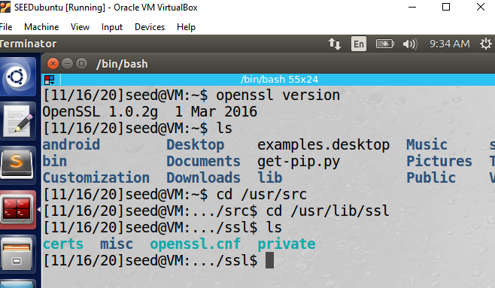

Ran the commands to generate a self-signed certificate.

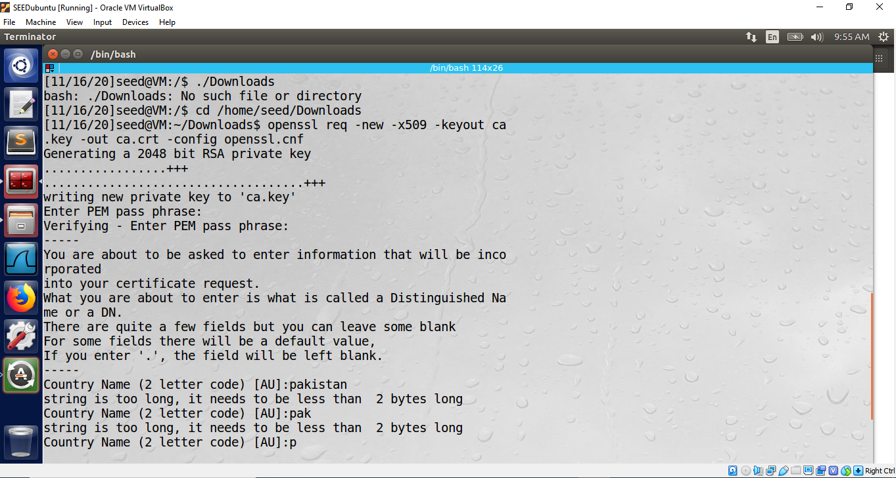

Certificate generation took some input of information.

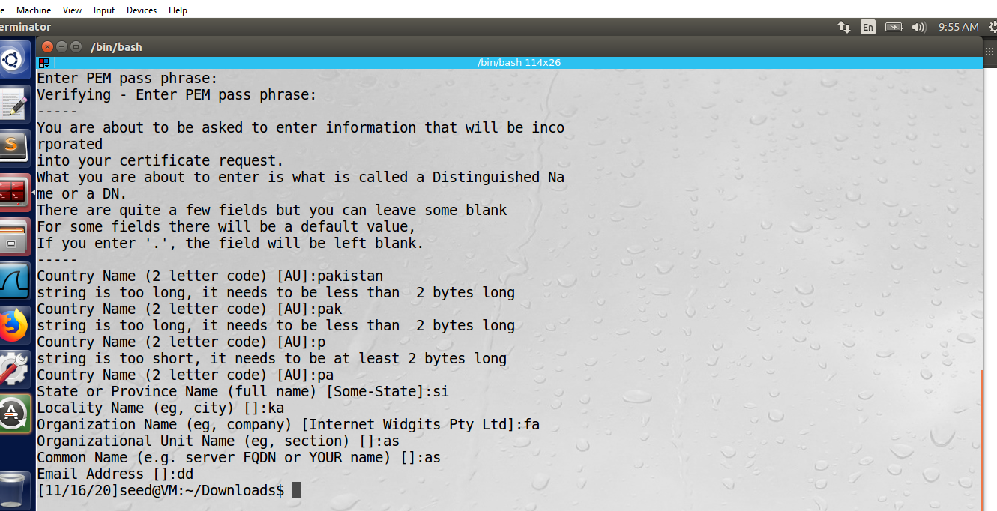

Generated certificate along with ca.key and ca.crt.

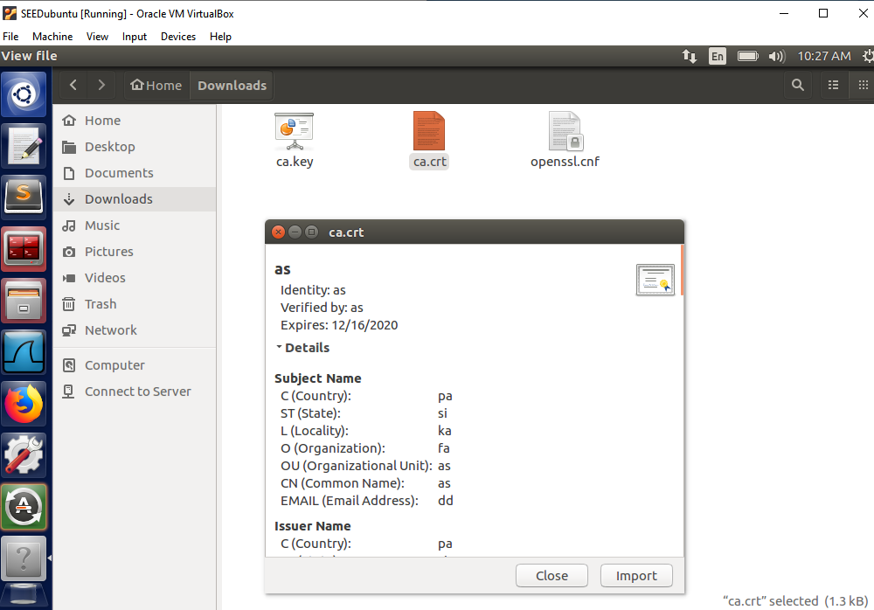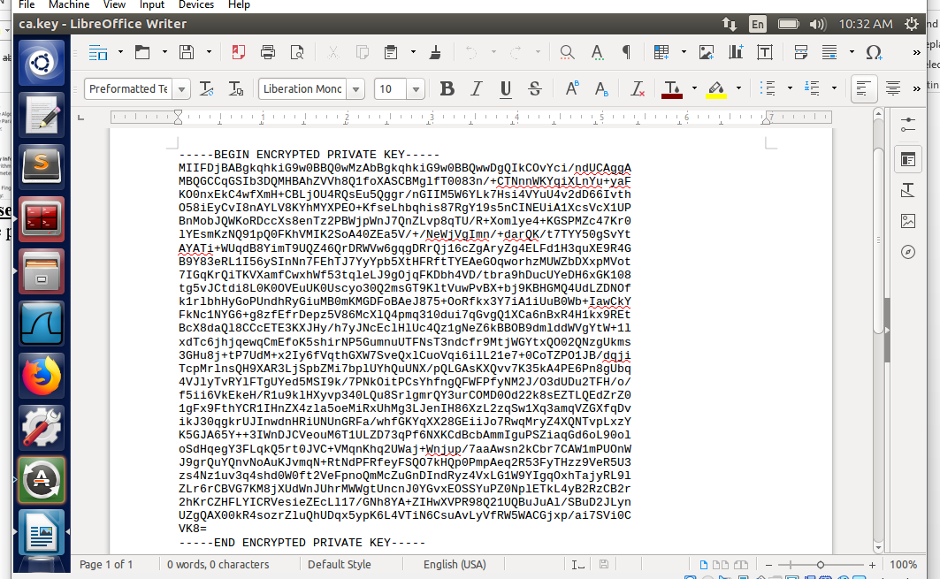

**TASK 2 – Creating a Certificate for SEEDPKILAB2020.com**

Step 1:

Ran the commands in correct directories to

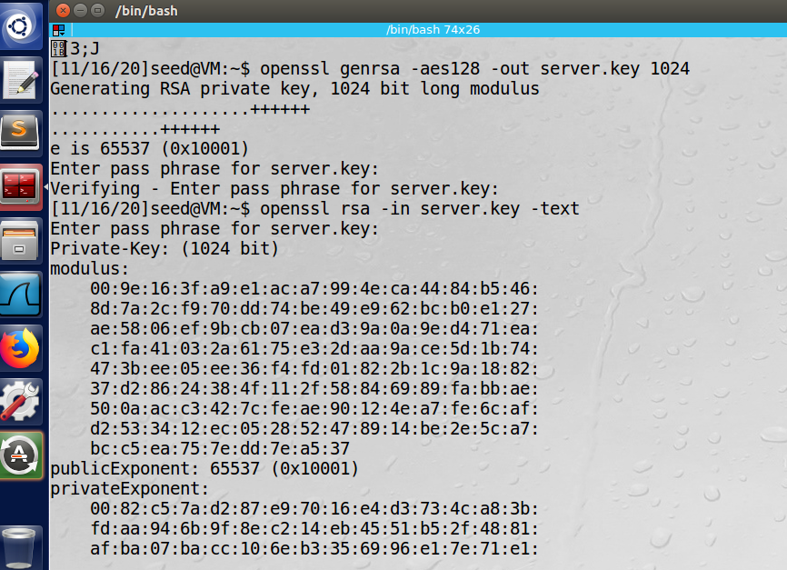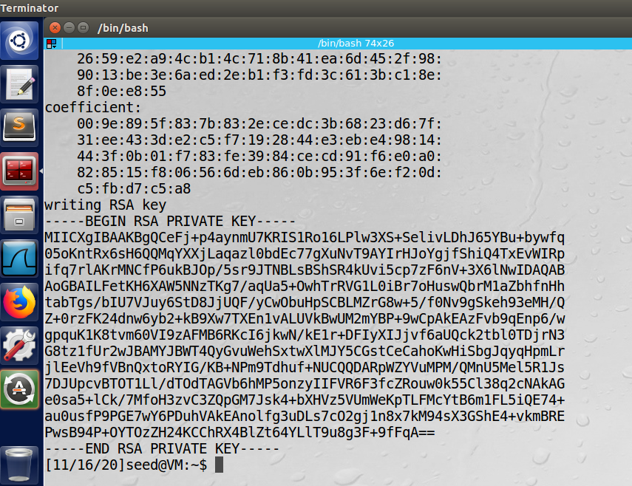

Step 2:

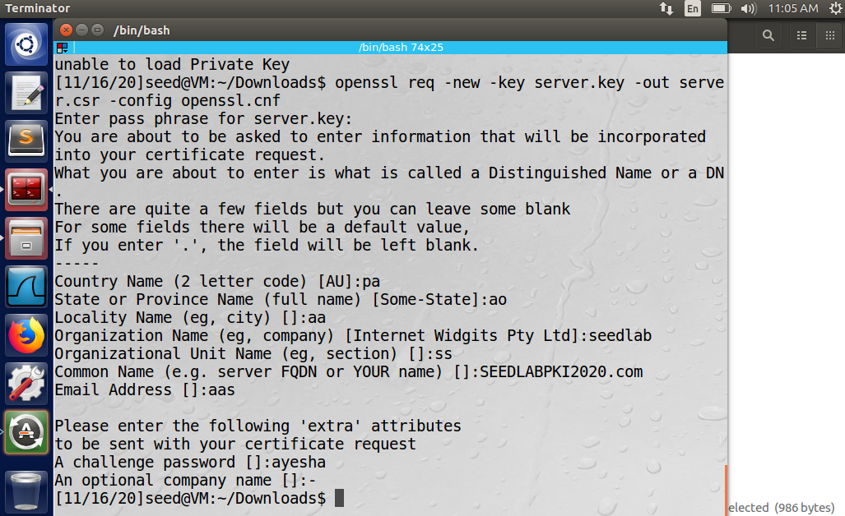

Step 3:

Certificate generation:

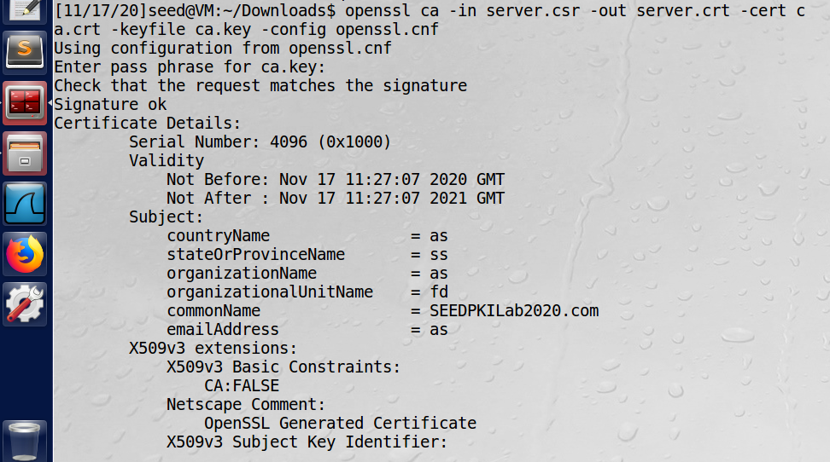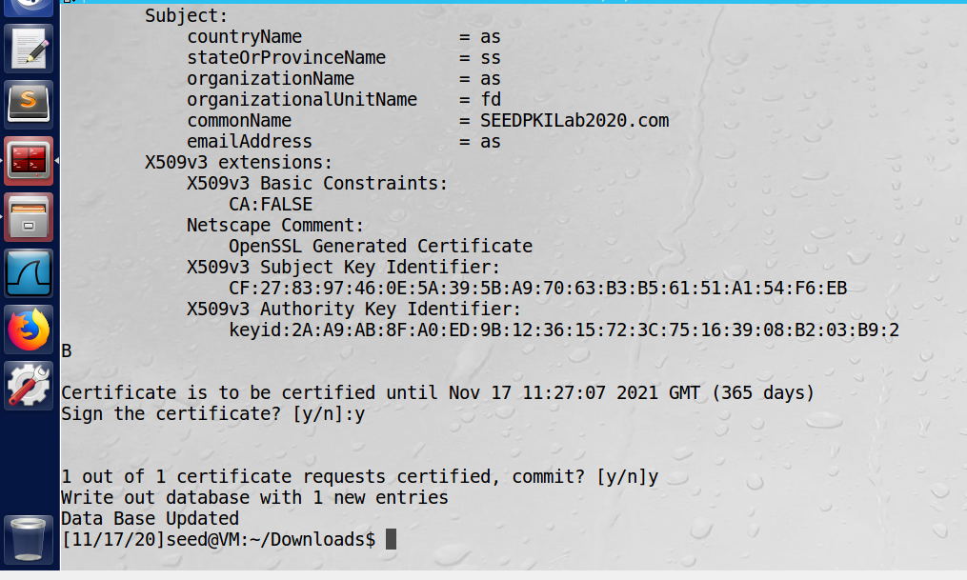

**TASK 3 – Deploying Certificates in an HTTPS Web Server**

Step 1:

Accessing the directory

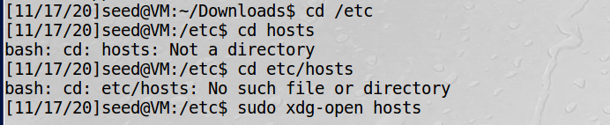

Editing the host file:

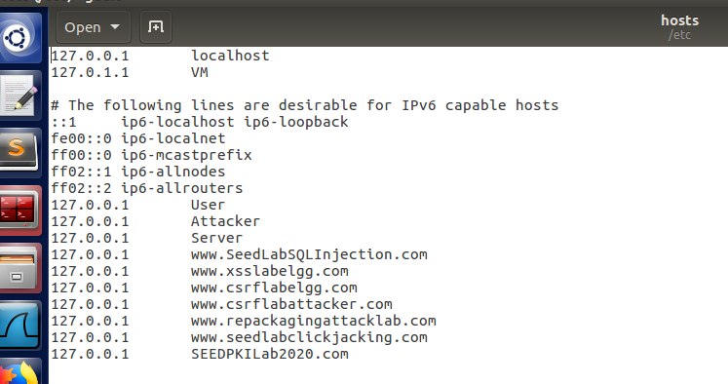

Step 2:

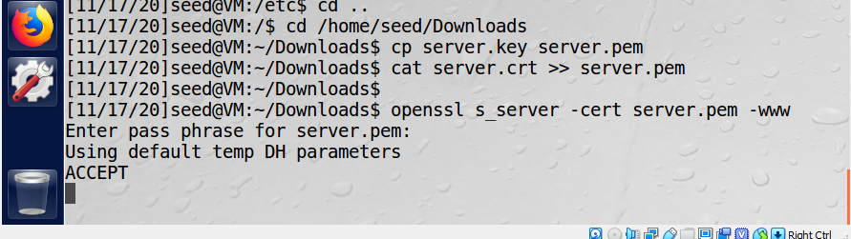

Firefox output of warning:

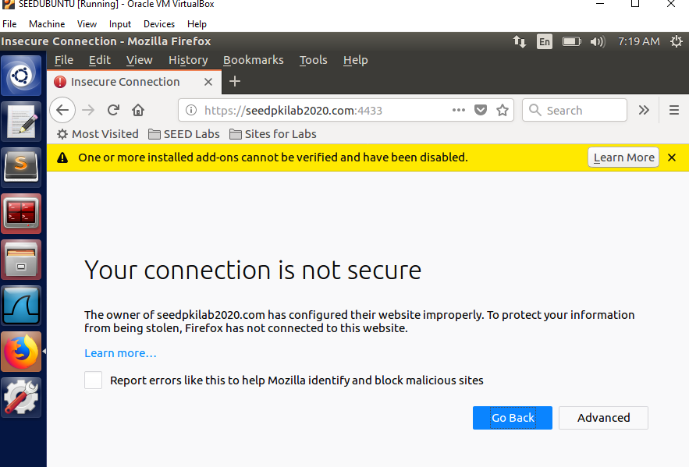

Step 3:

Importing the certificate to get it authenticated as a trusted party.

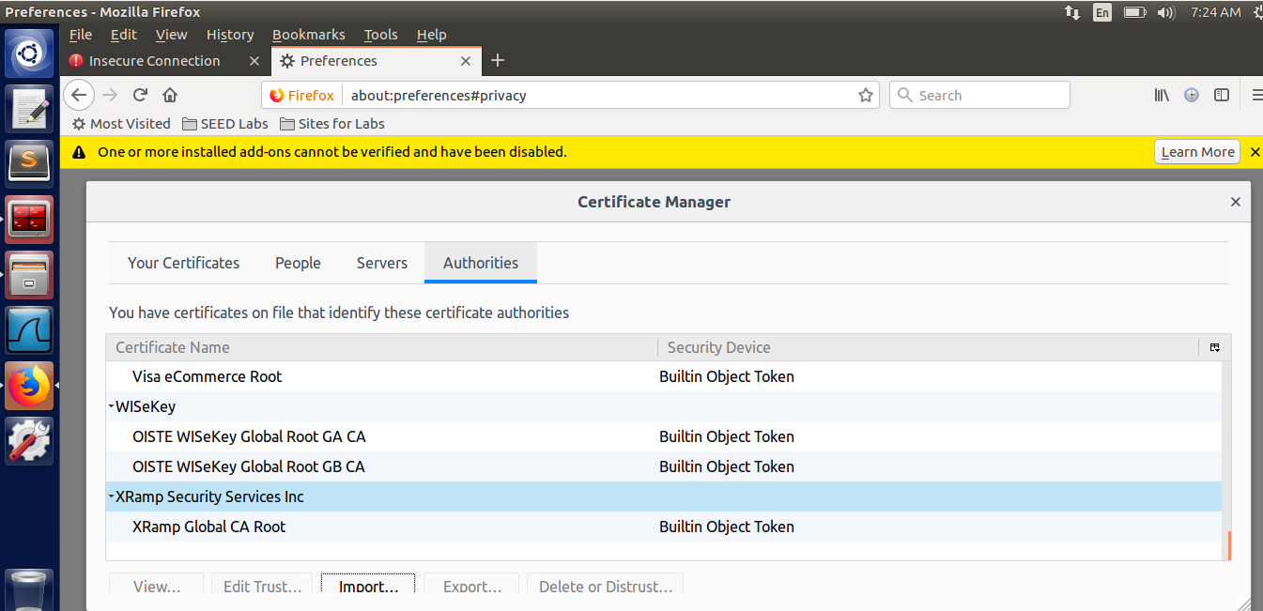

Step 4:

**Part 1:**

Output on browser without modifying the bit. Since the certificate was verified now, the link was accessible without any error and the contents is visible.

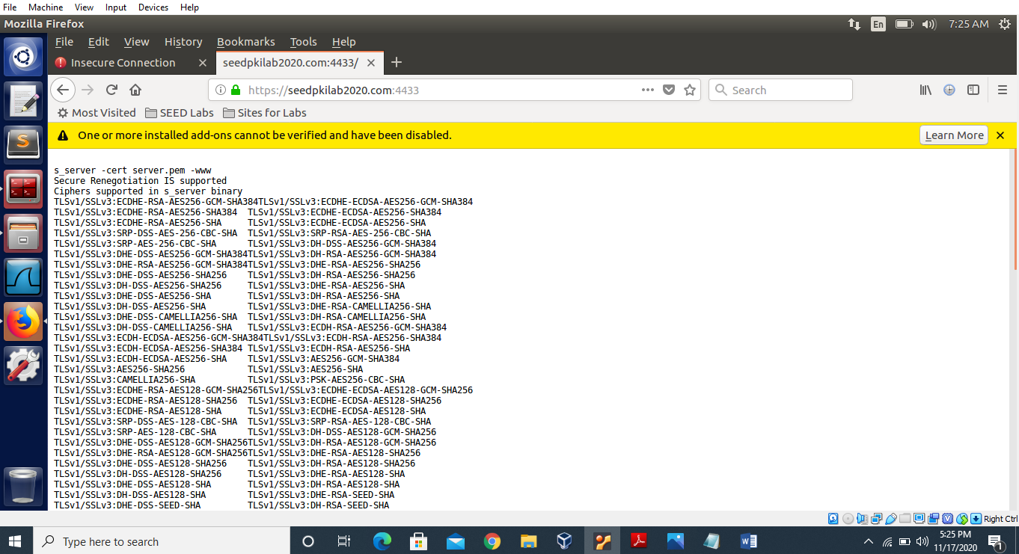

Opening the certificate to modify the bit:

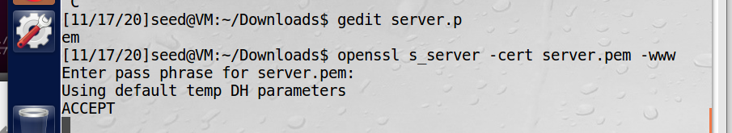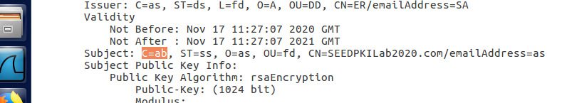

Output on browser after modifying one bit. We can still reload the URL and see output on browser.

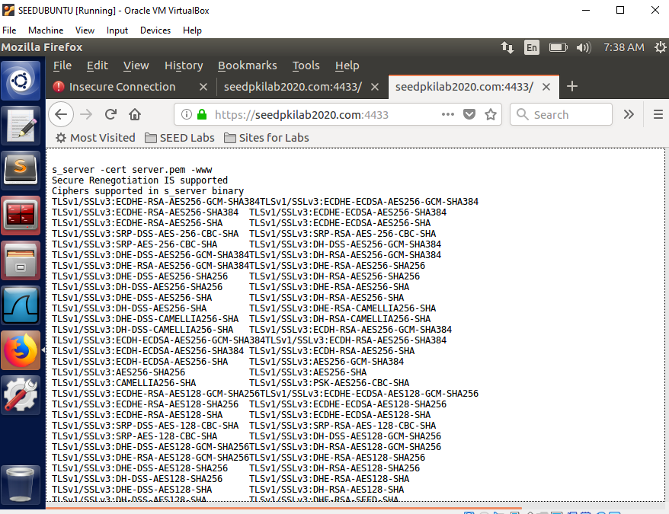

**Part 2:**

Output on browser on localhost. Since certificate is not trusted, therefore it does not open it.

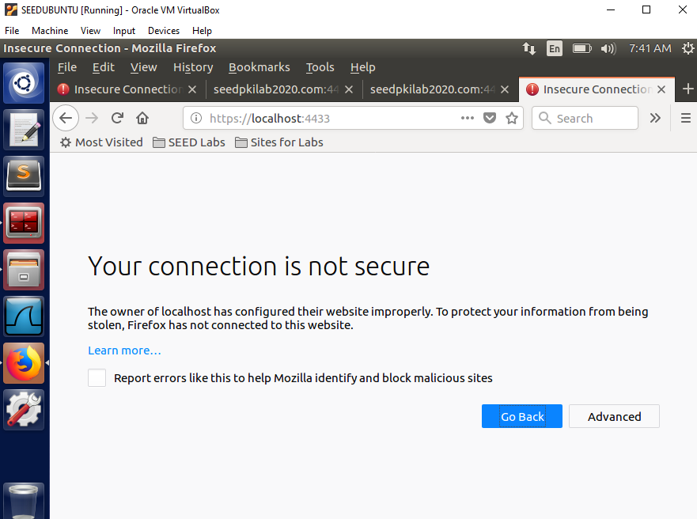

**TASK 4 – Deploying Certificates in an Apache-Based HTTPS Website**

Accessing the directory:

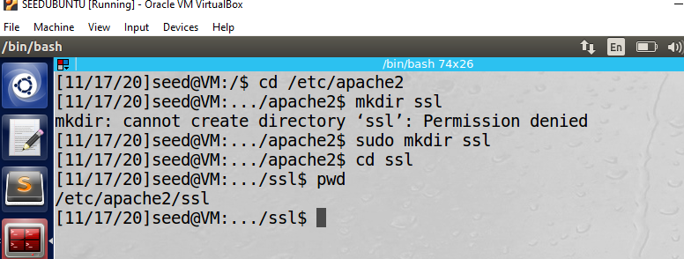

Copying and creating further files

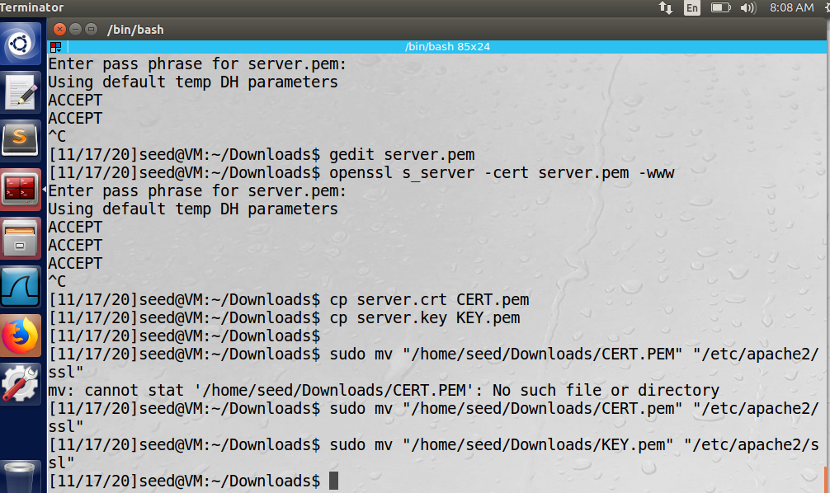

Added following commands in 000-default.conf:

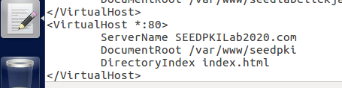

Added following commands in default-ssl.conf:

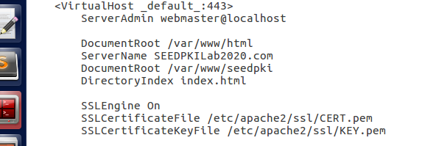

Added following commands in apache2.conf:

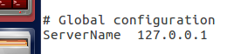

Creating further directories to run commands properly:

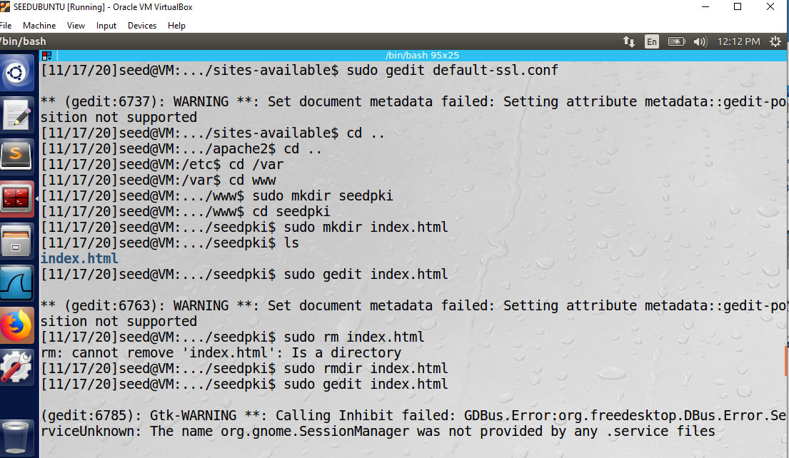

To encrypt traffic and enable openssl:

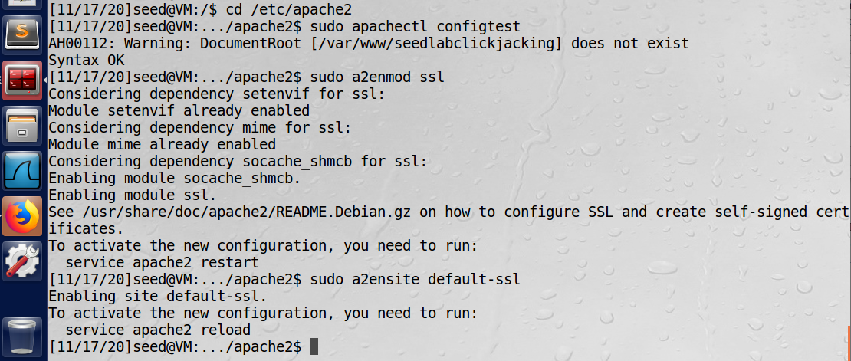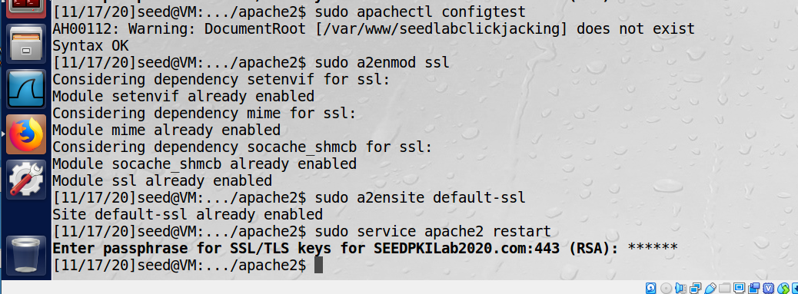

Desired output on Firefox:

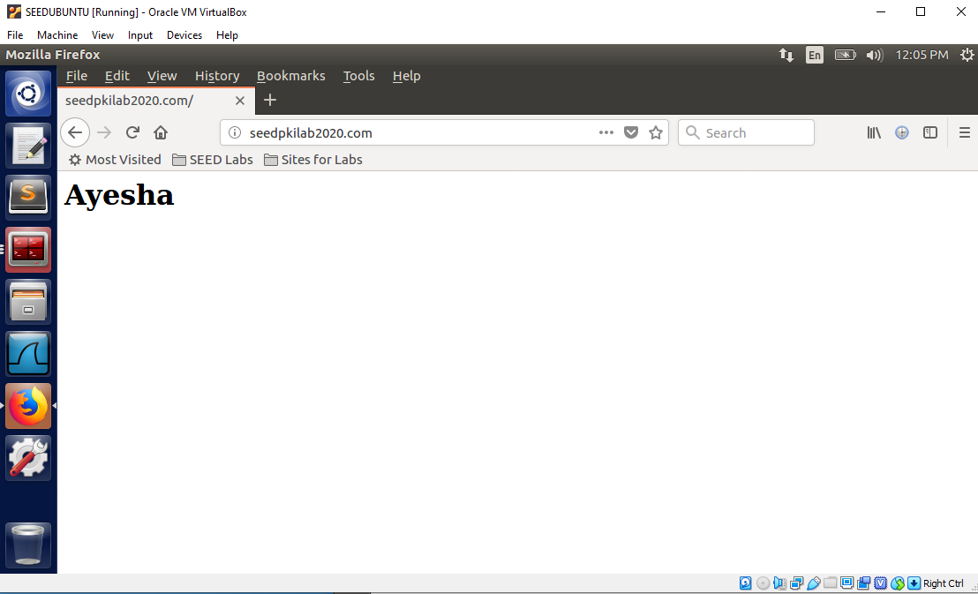

**TASK 5 – Launching a Man-In-The-Middle Attack**

Accessing the configuration file to edit it

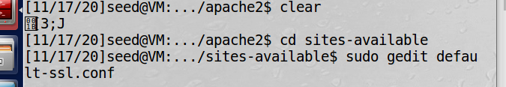

Adding a virtual host for facebook.com in the default-ssl.conf file:

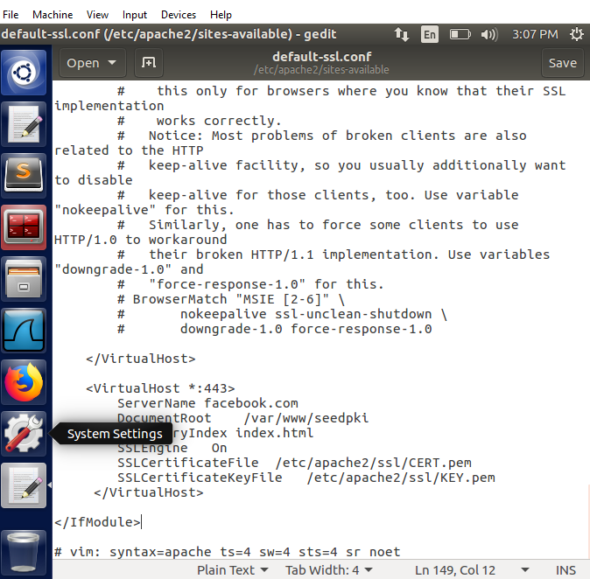

Running few commands written in manual.

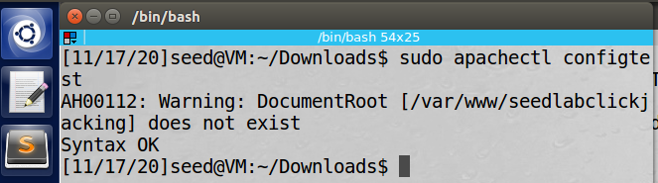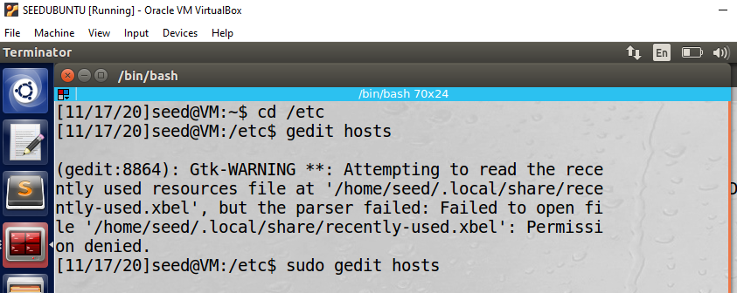

Adding fake website IP address to the /etc/hosts file.

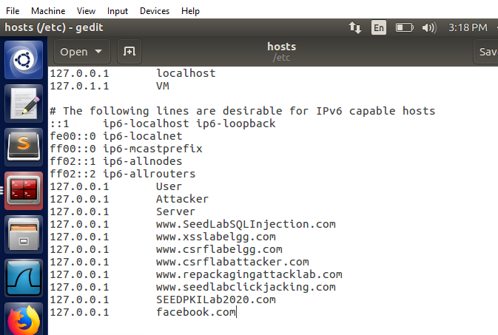

Now every time a user visits facebook.com, the user will land on the server where our fake website is being hosted. But fake website html page is not displayed because its certificate is not deployed on the apache server.

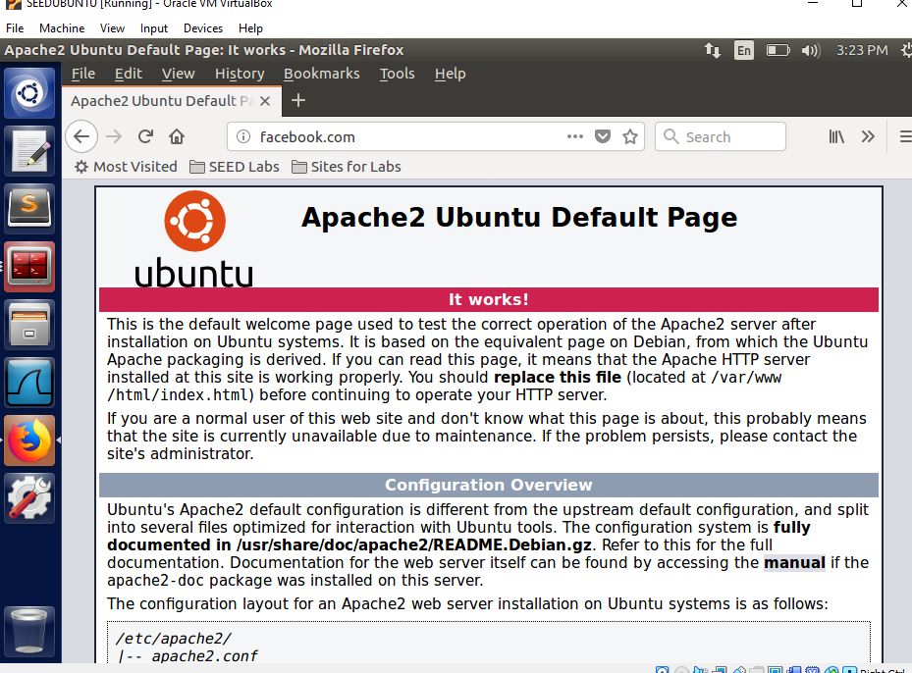

**TASK 6 – Launching a Man-In-The-Middle Attack with a Compromised CA**

For a successful MITM attack, we have created and added the certificate to the Apache server.

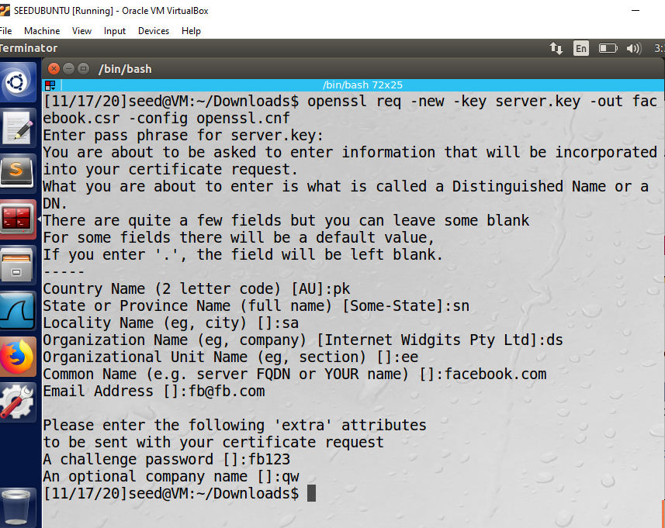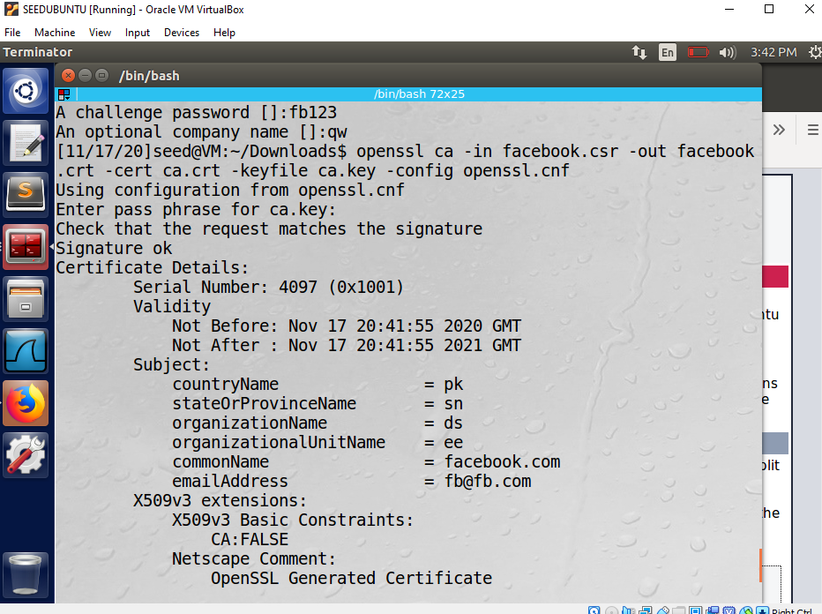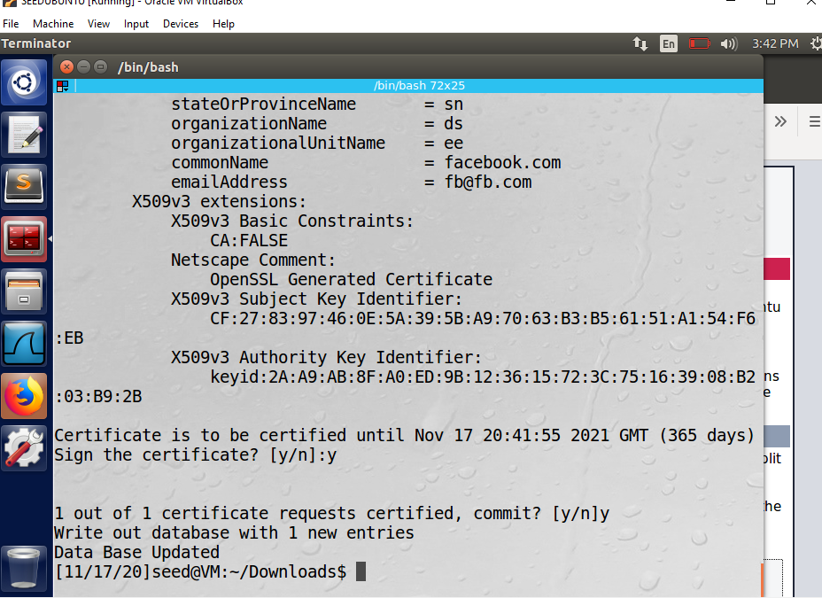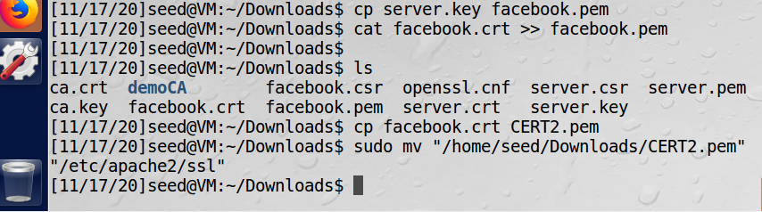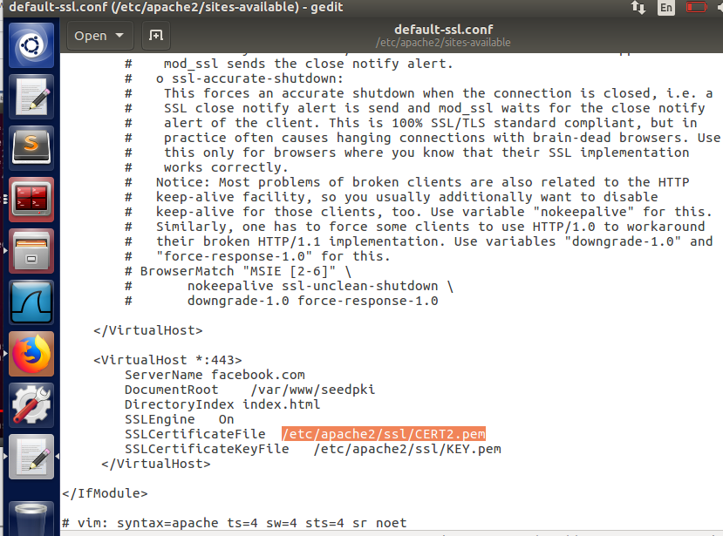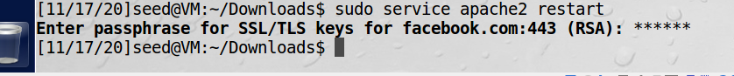

After running commands and making changes in files, the user is displayed the fake website html page.

